**Report**

1. **Accessing the Website**

Once unzipped, open the folder, run the project, and the website will be rendered in the browser.

2.**Website Layout**

The overall layout of the website is presented: **horizontal navigation** (home, city, attractions, contact), **main image, content,** and **footer.**

General layout：

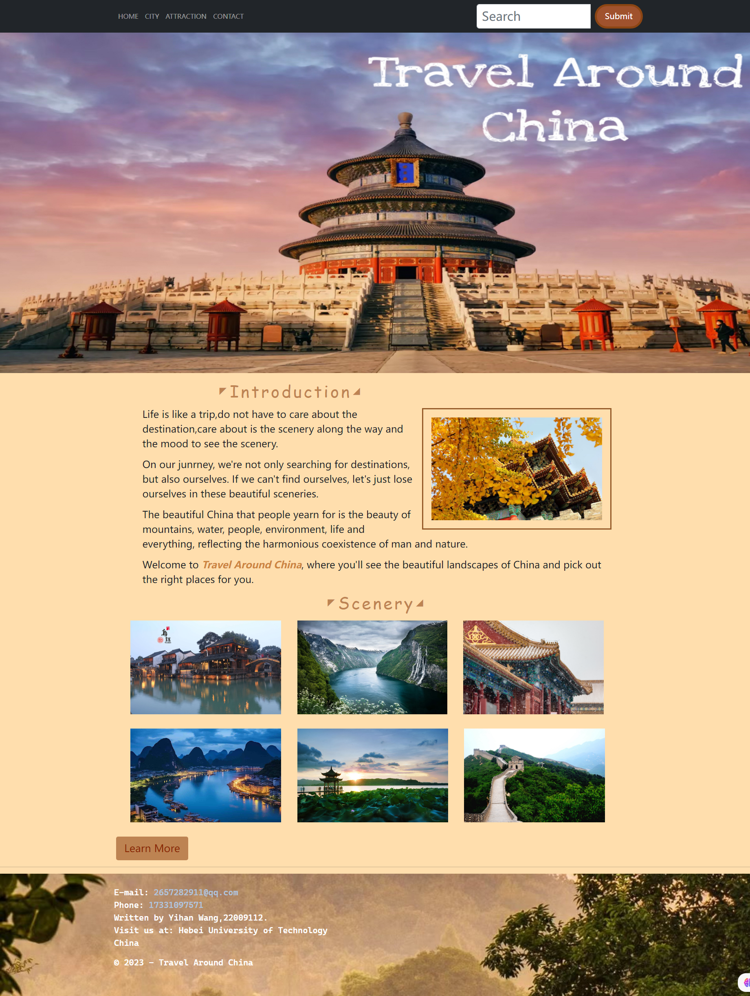

**Horizontal navigation**

**Content**

**Footer**

Main image

In the home page, the top is the **horizontal navigation**, and the lower **main image** occupies the upper part. The **title** is added and the website is introduced, the **picture** and its border are added on the right. **Next title** and six pictures are added above the footer, the beauty of China is shown on the home page, a jump **button** is added at the bottom left, and the **footer** part at the end of the page is the footer part.

Home Layout：



Button

Title

Image

Title

**Footer**

Main image

**Horizontal navigation**

On the city page, two **text** and **picture** parts are added below the main image, the picture layout is staggered, and six picture frames are designed below, each of which has **pictures and links.**

City Layout：

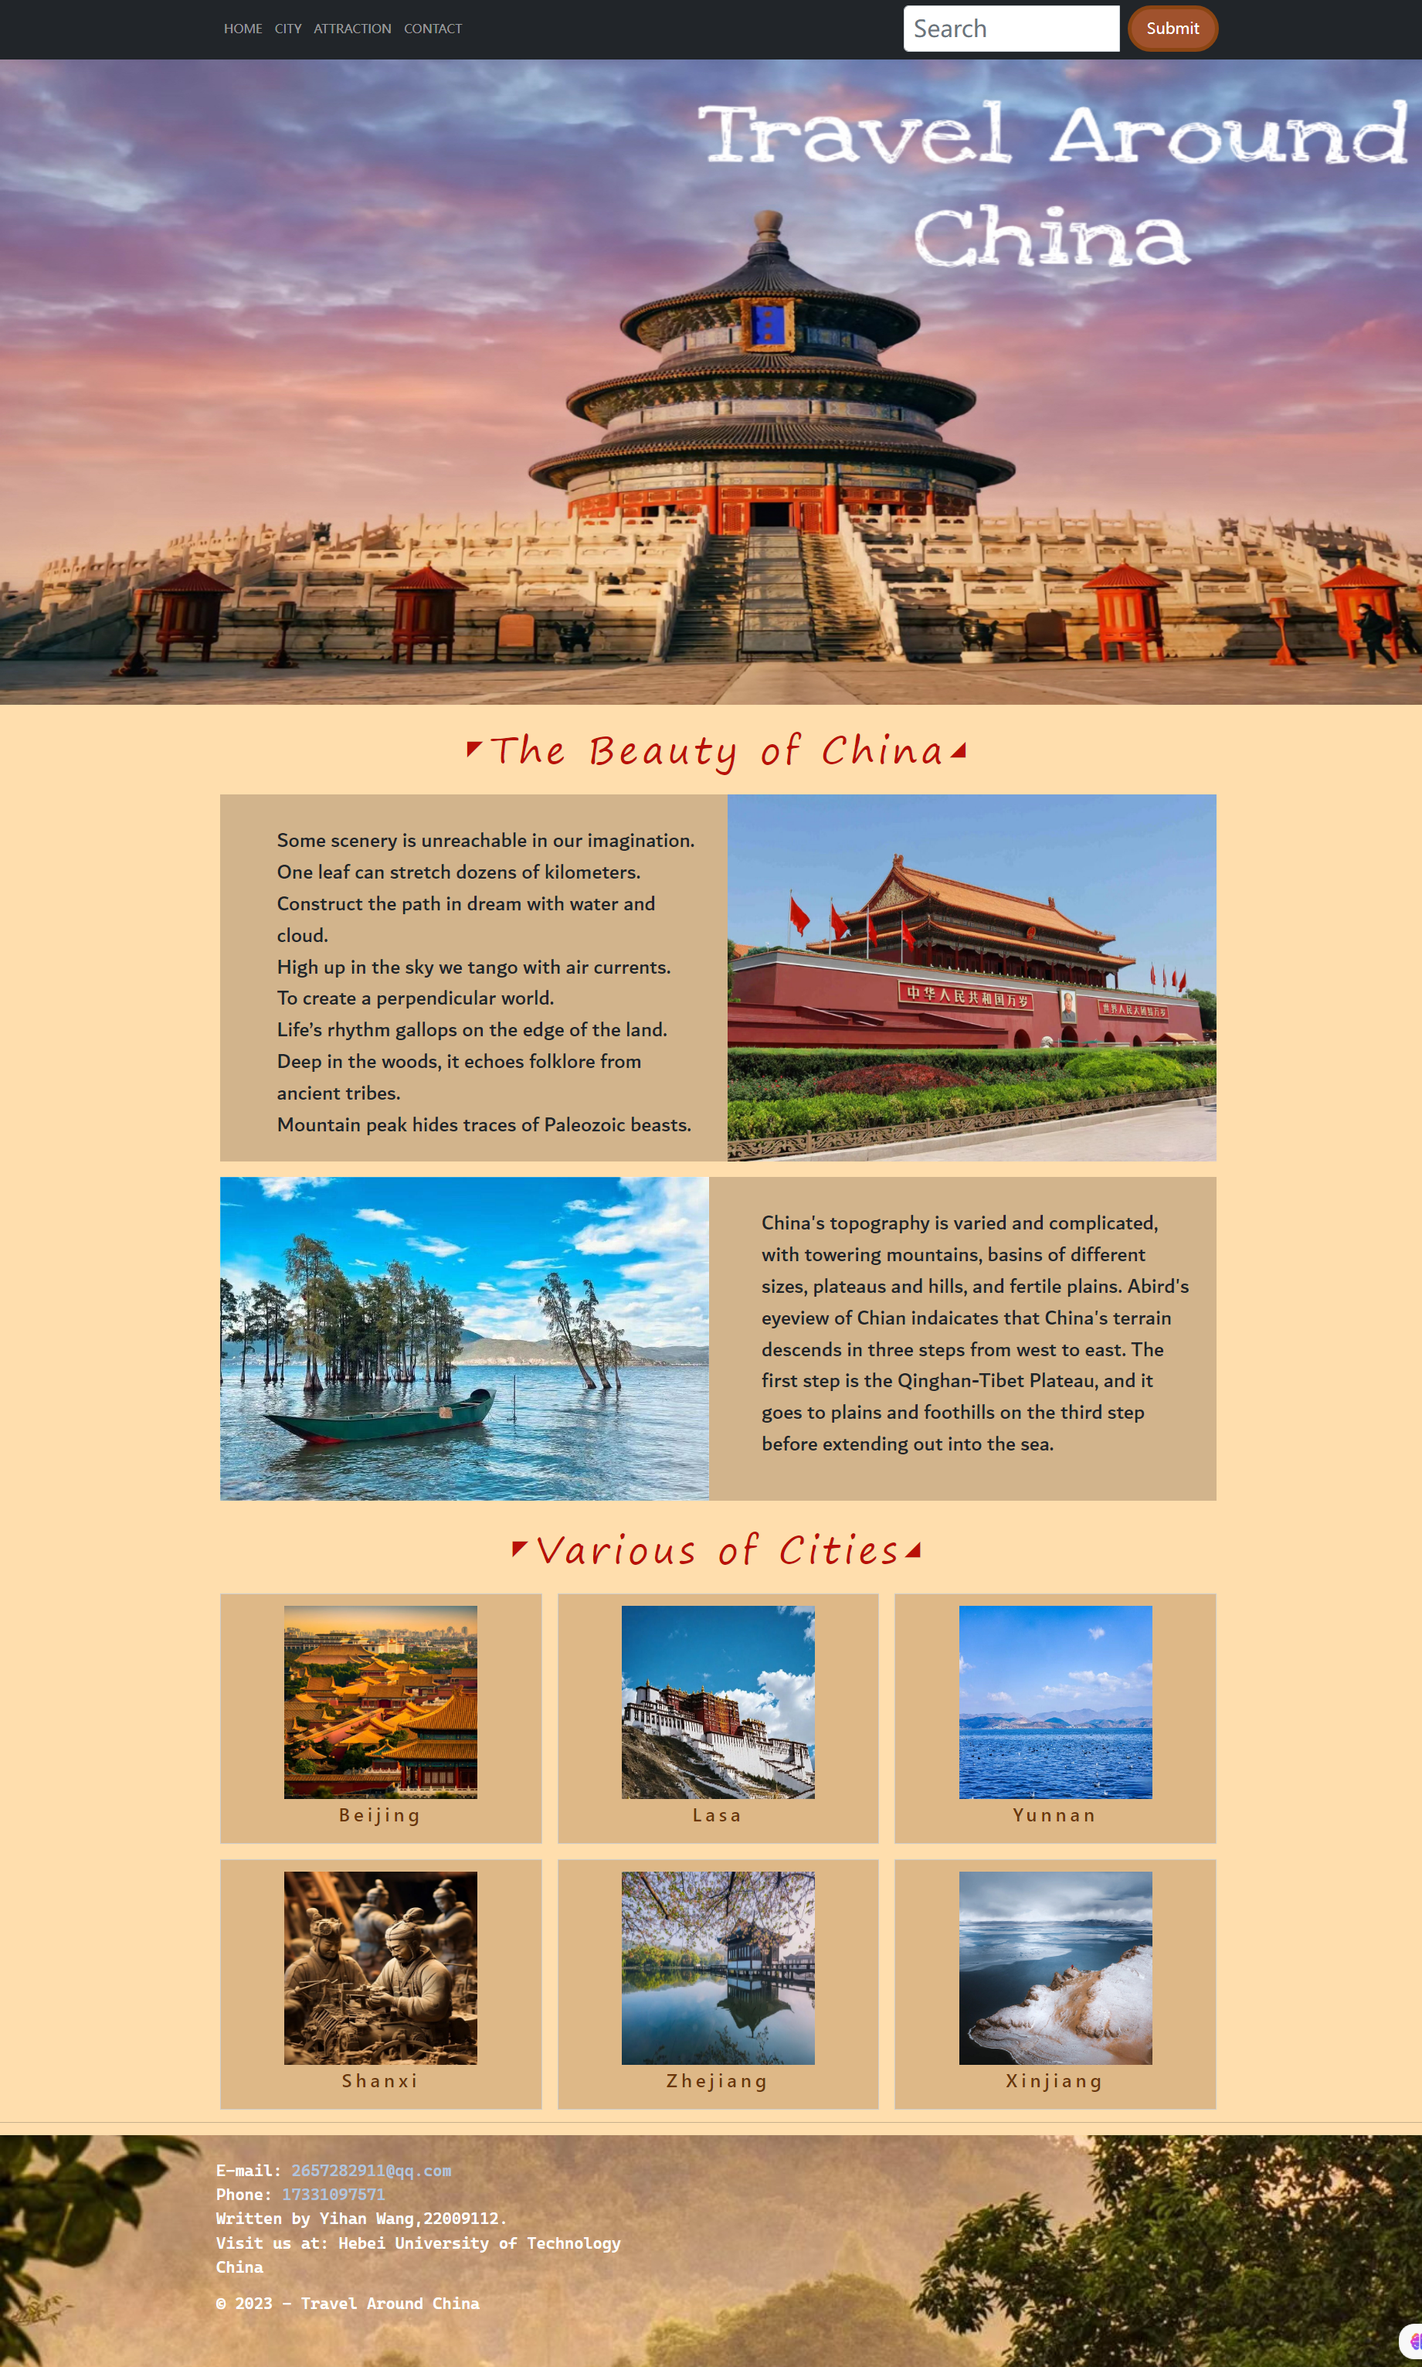

**Footer**

**Horizontal navigation**

**Title**

**Model：City**

Text Image

Text Image

**Title**

Main image

**Horizontal navigation**

There is a **filter button** below the main image of the attraction page, and I used the form of **introduction** on the left side of the **picture** on the right to present the attraction, which is listed in turn, and the pagination **page number** part is set above the footer.

Attraction Layout：

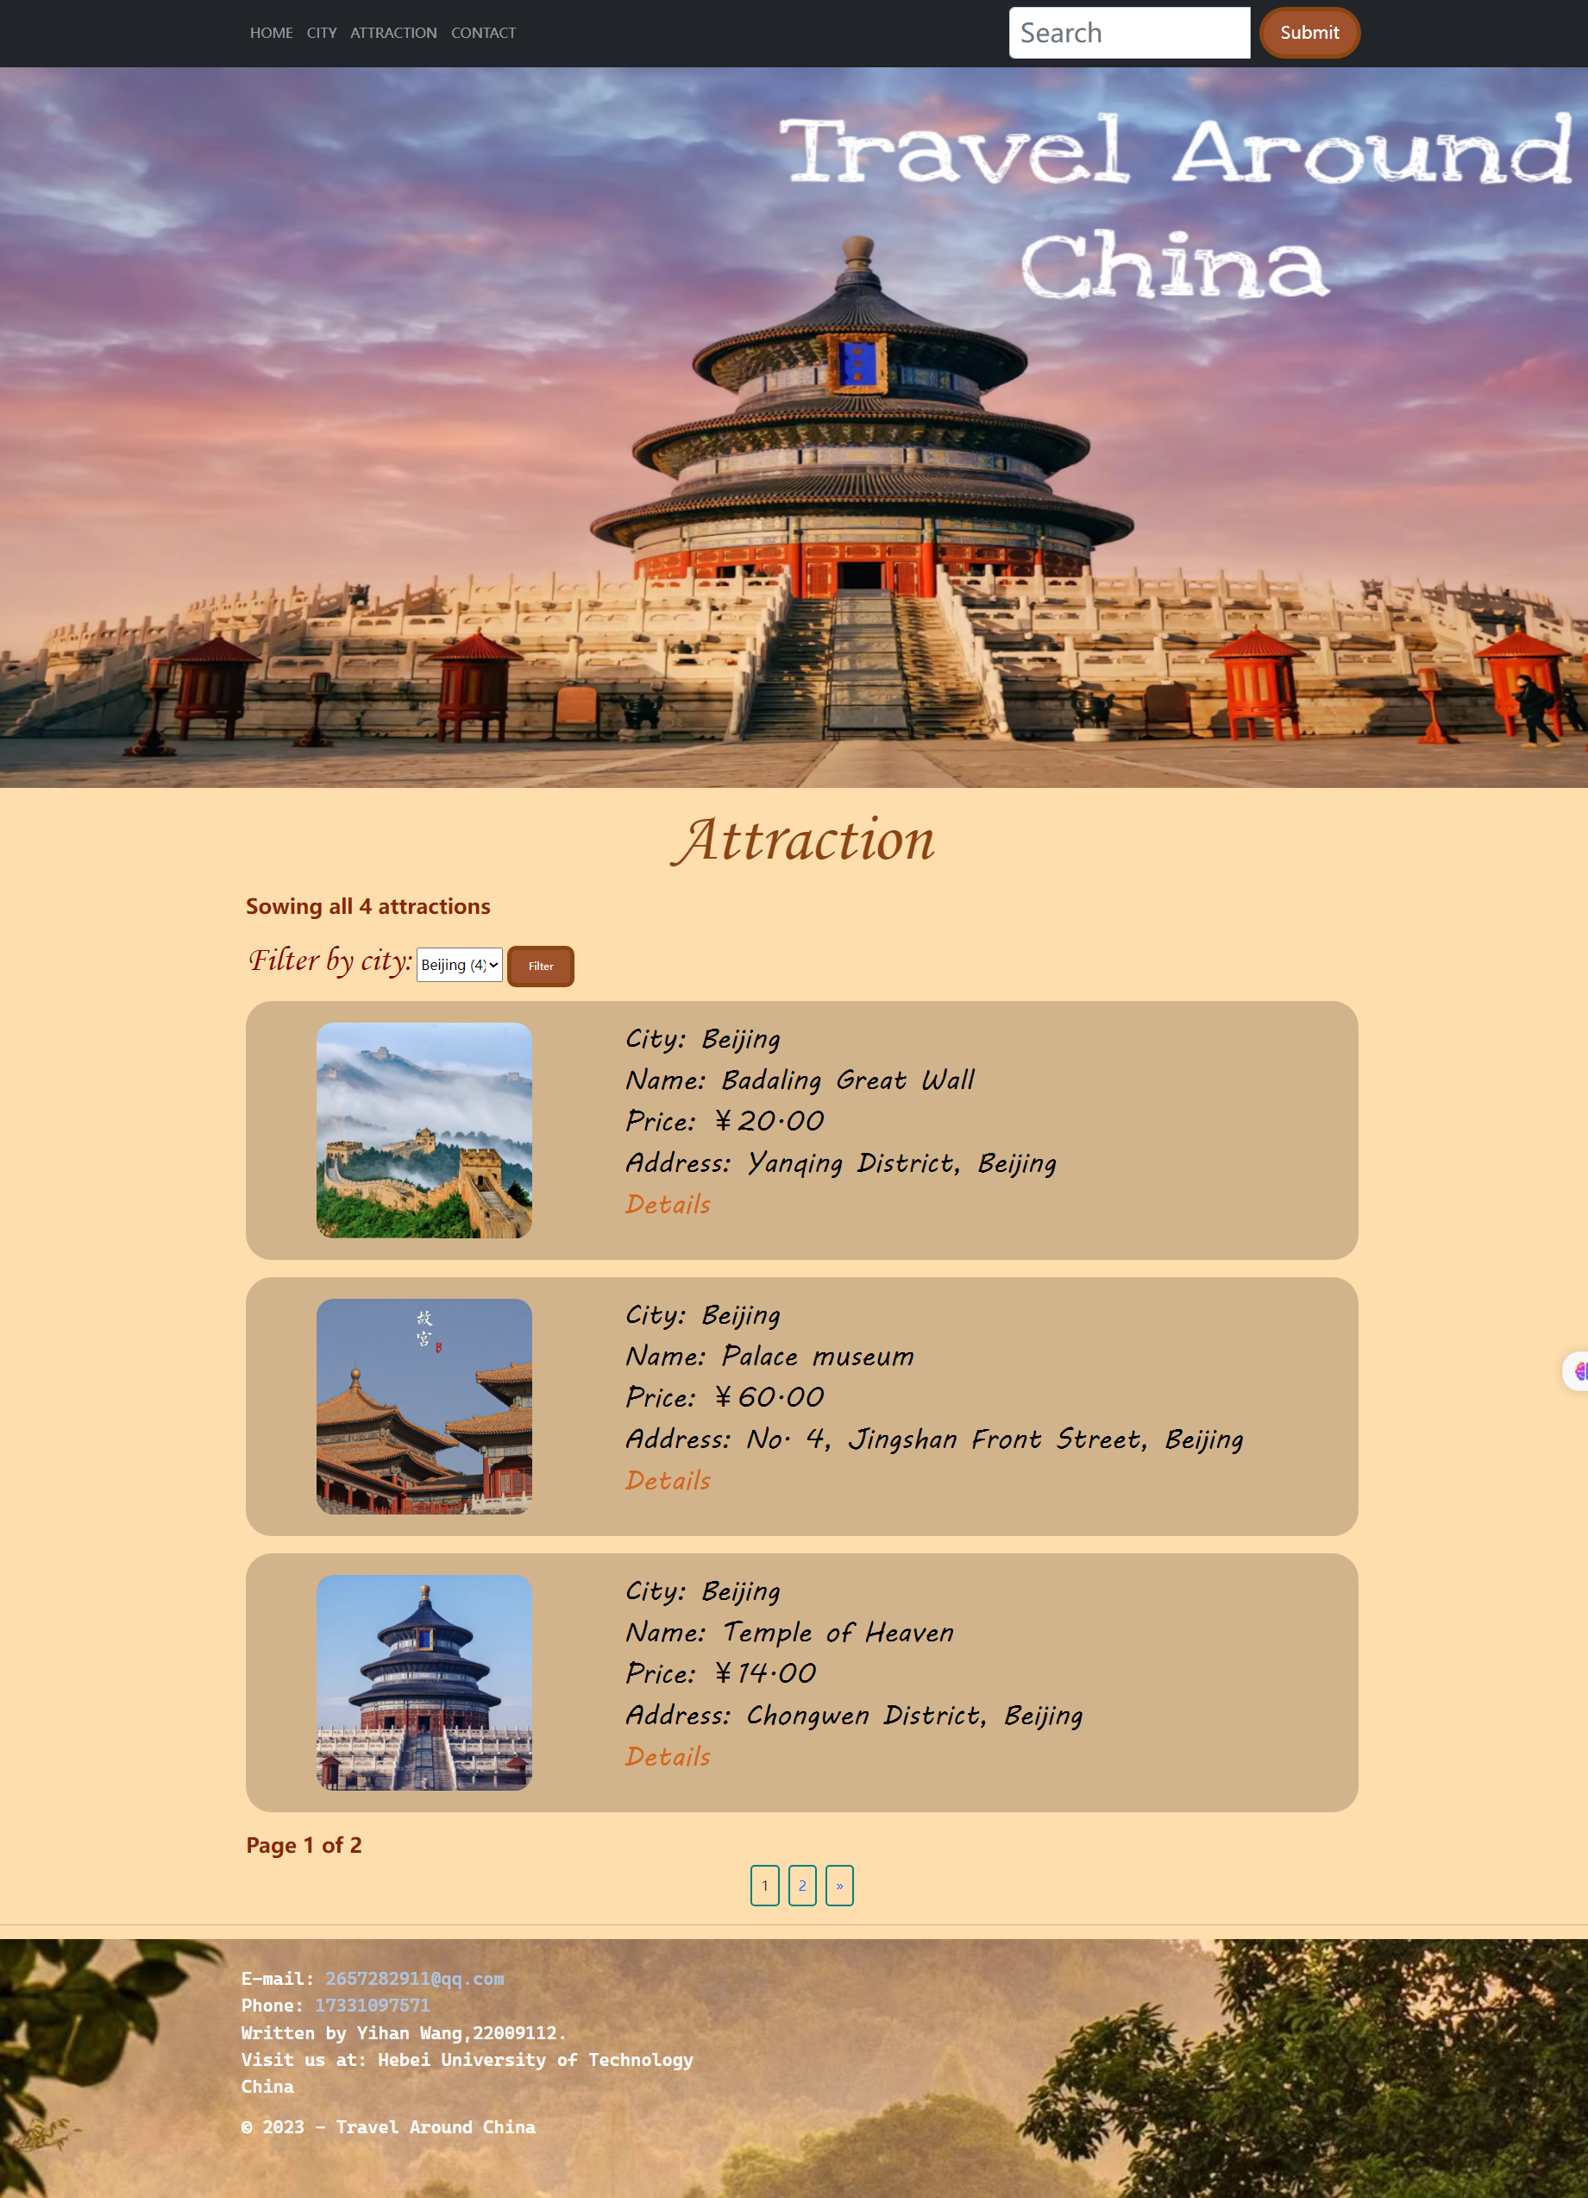

**Horizontal navigation**

**Footer**

Page

Image Attribute

Image Attribute

Title

Filter

Main image

On the Contact page, add two levels of **headings** below the main image, and below that is the feedback **form** and **submit button**.

Contact Layout：

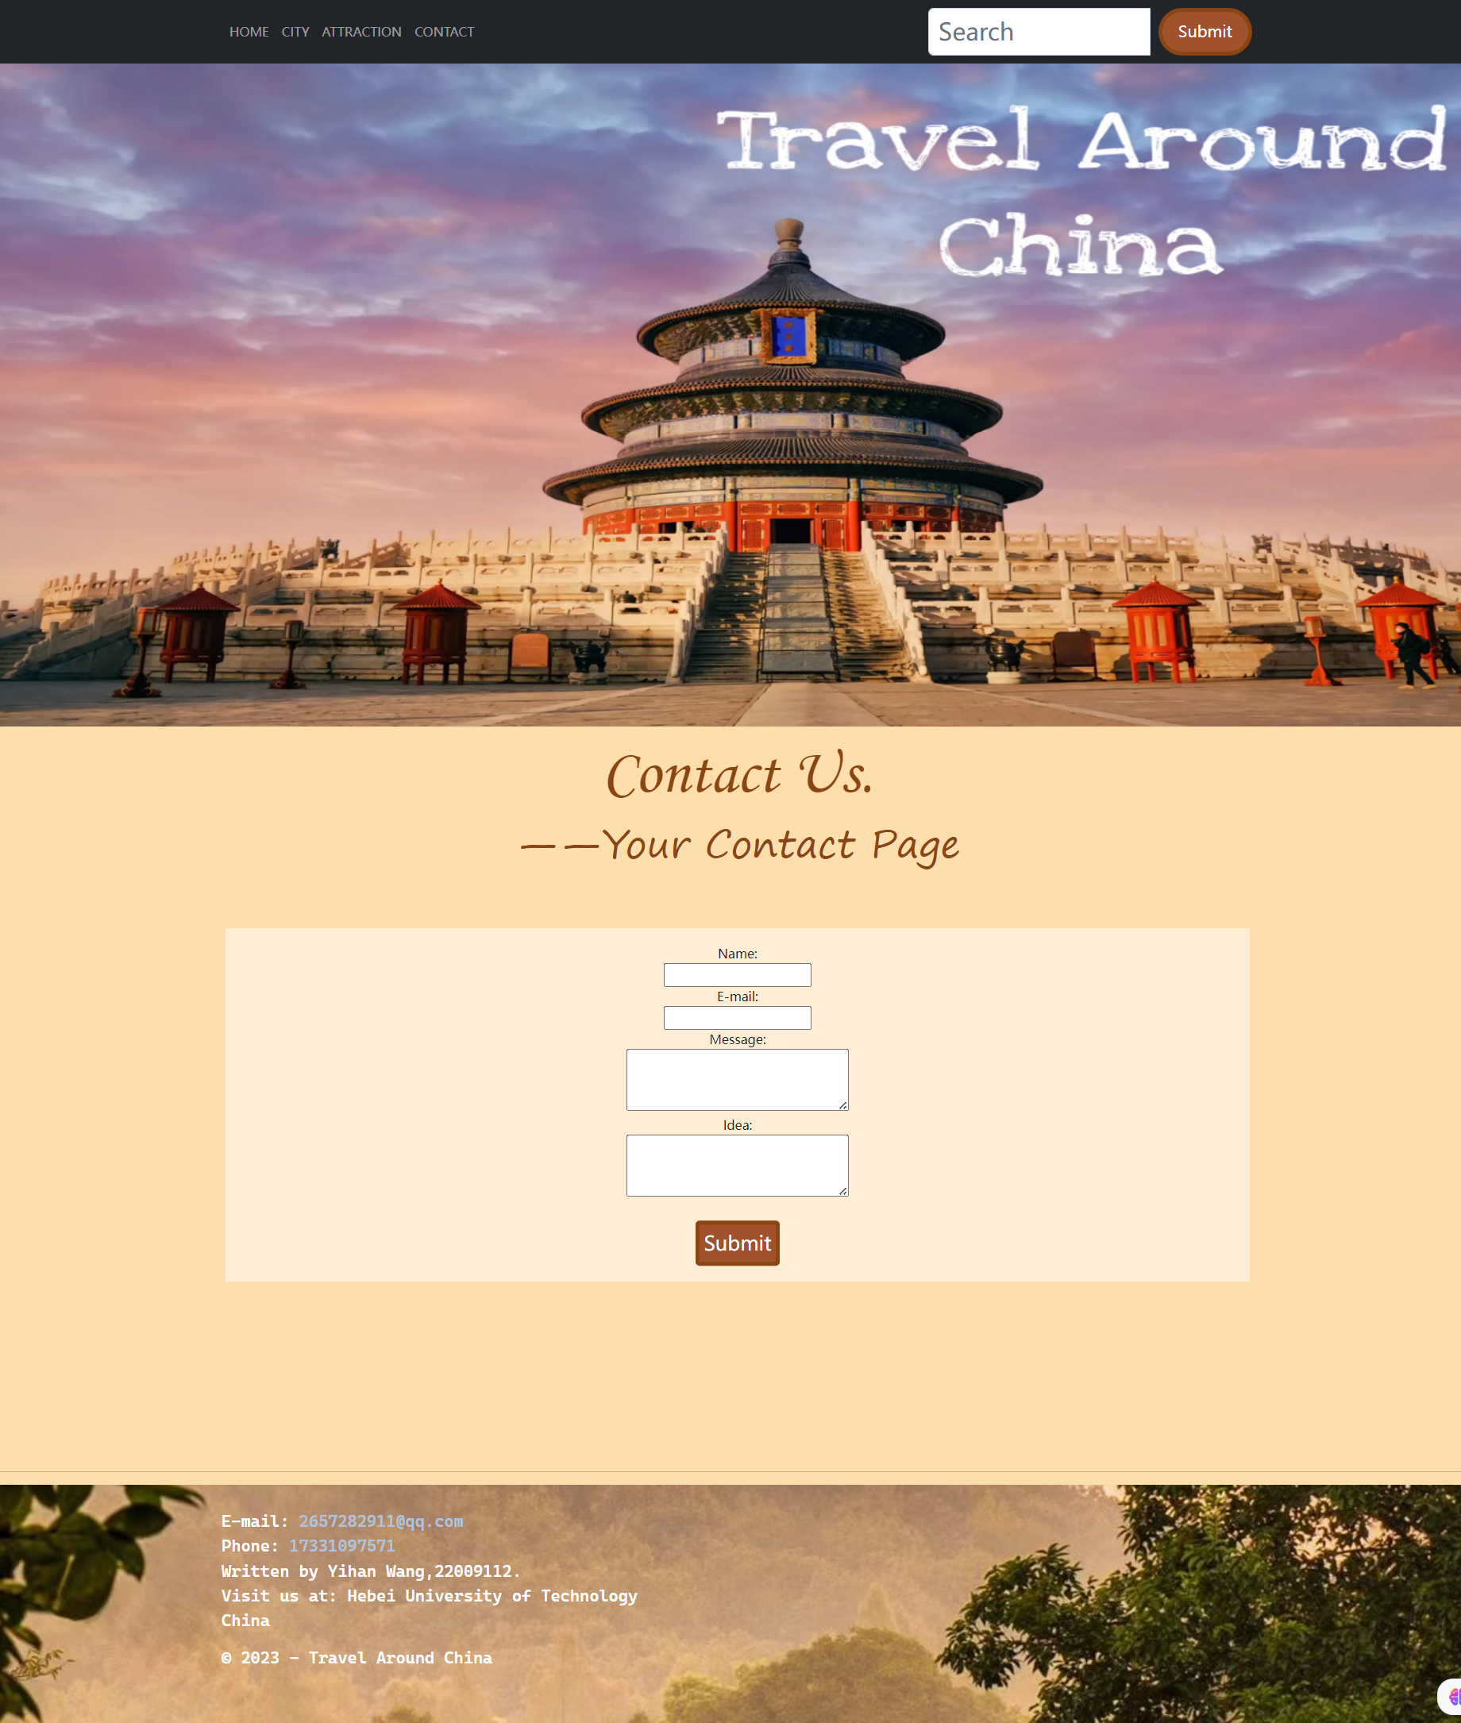

Title

**Footer**

Main image

**Horizontal navigation**

Button

Table

**3.Utilizing Website Features:**

**Horizontal navigation:** Click to jump to the corresponding page, enter the content in the search box and click submit to query the search content on the attraction page.

eg.



**Travel Around China** link: Click to be redirected to another website with aerial footage of China.

eg.



**Learn more** links: Click to go to the City page.

eg.

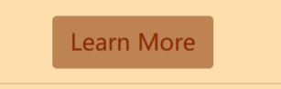

**City** Link: Click to jump to the Attraction page, which only introduces the attractions in the selected city

eg.

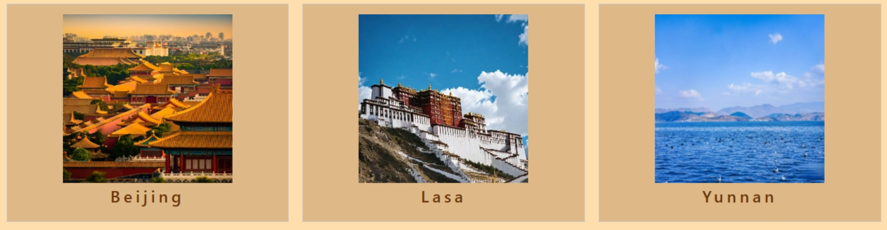

**Filter** function: filter by city, select a city, and only the attractions that belong to the city will appear on the page

eg.

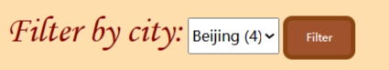

**Details** link: Jump to the details page to present the attributes of the attraction.

eg.



**Back to list** link: Click to return to the Attraction page

eg.

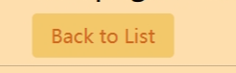

**Page numbering**: Click on the page number to jump to the corresponding page number section to show some attractions

eg.

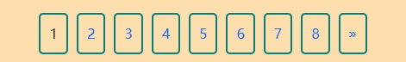

**Feedback form**: After filling in the content, click Submit, and a pop-up window will appear to show that the submission is successful

eg.

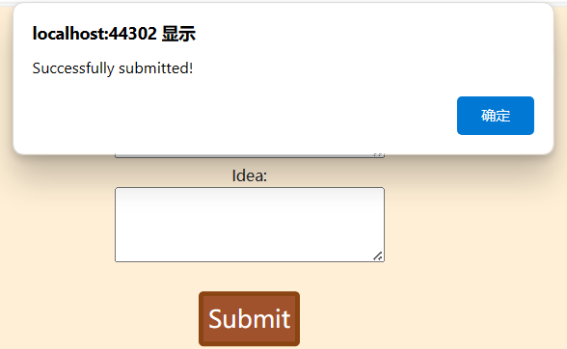

**E-mail and phone:** Click to call or send an email to contact us.

eg.

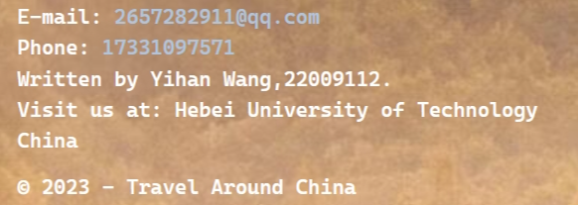

**4.Technical Demonstrations:**

**4.1Model：**

I created two models, three properties were added to the city model: ID, Name, Attraction List. Five public properties have been added to the attraction model: Name, Address, Price, CityID, City. **Attraction List** and **City** are navigation properties and this makes associations between entities in the model.

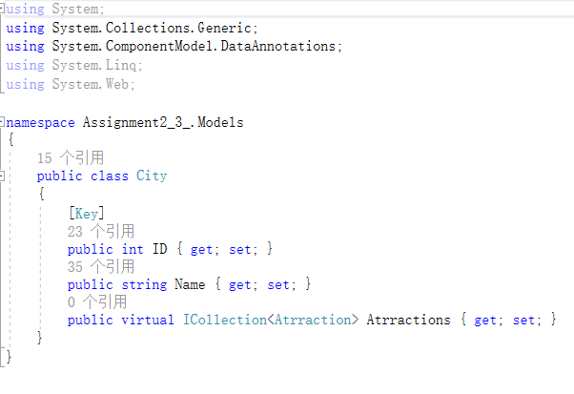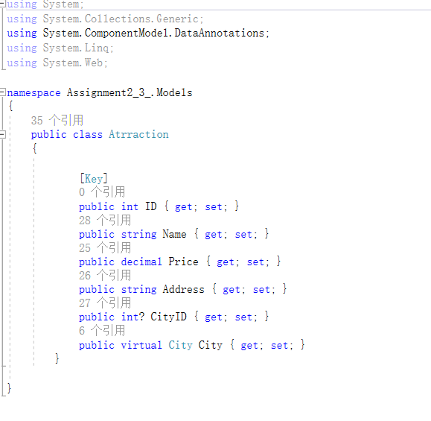

**4.2CSS：**

There are a few commands that make good use of changing the style of a web page, such as: color, font, text-align, text-decoration, background, width, height...Some styles are in external CSS files, and some styles are set in HTML. For example:

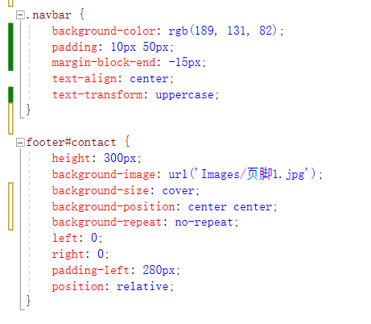This is what I added in Site.css to add styles for horizontal navigation at the top of the page, including things fonts and background.

This is a styling modification for the footer, adding a background image, setting the height and relative position.

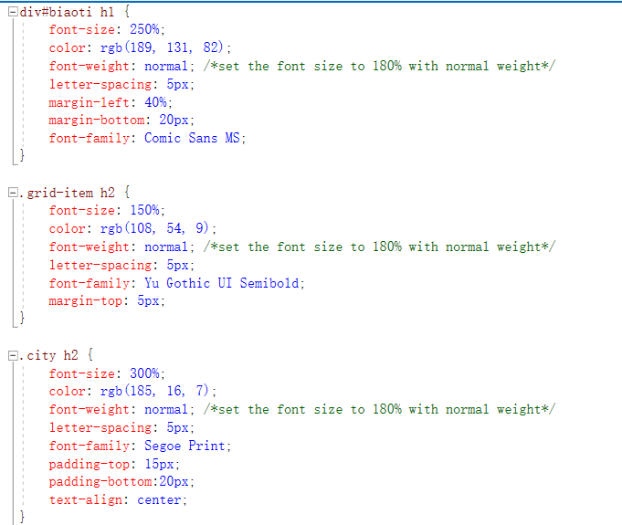This is a style design for the homepage title font, designing the font style, size, spacing.

This is a font design for the six cities in the City page, including font style, color, and top spacing.

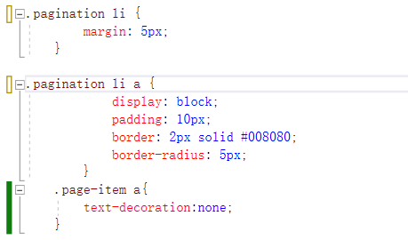

This is a design for pagination page numbers, with borders added and rounded corners, page numbers centered, and underlines removed.

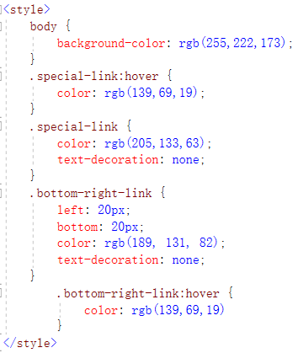

This is the styling design in the City page, with the background color changed, the link color and the underlining removed.

**4.3JavaScript**

Create a **MyJavaScript .js** file and write a method**(alert)** to pop up a pop-up box to prompt the successful submission.



**4.4Feature Implementation：**

4.4.1 Search：

For the search function, I used a **keyword search**, and the user entered the text and the attractions that contained the keyword were searched. You can search for **City.Name, Attraction.Name, Attraction.Address,** and

store the search keywords in the **viewModel.Search** property so that they can be displayed in the view.

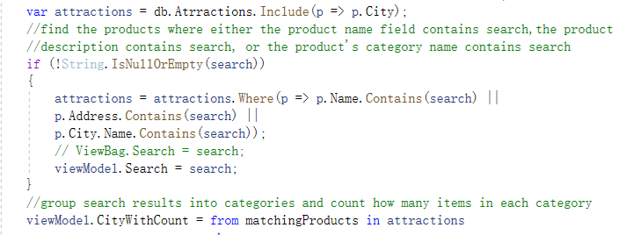

4.4.2 Filter：

Only attractions with non-empty City ID were selected and grouped by the city name. A new CityWithCount list object was created with the city name and the number of attractions that the city contains. Check again, if City is not empty, filter the attractions to select only those attractions whose city names match the city, and store them in viewModel.City.

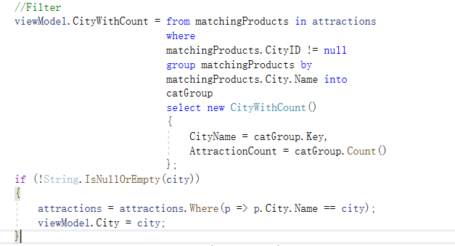

4.4.3 Page：

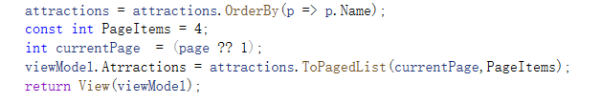First, I downloaded **PagedList.MVC** to enable pagination and make it easier to manage the data, the **PageItems** object sets the number of attractions to be displayed per page, initializes **currentPage**, sets **viewModel.Atrractions** to the pagination list of attractions, uses the **ToPagedList** method, takes currentPage and PageItems as parameters and passes the pagination result to the **viewModel**, which is then passed to the view.

4.4.4 Sort

Sort the attractions in ascending order of **Attraction.Name**.

